

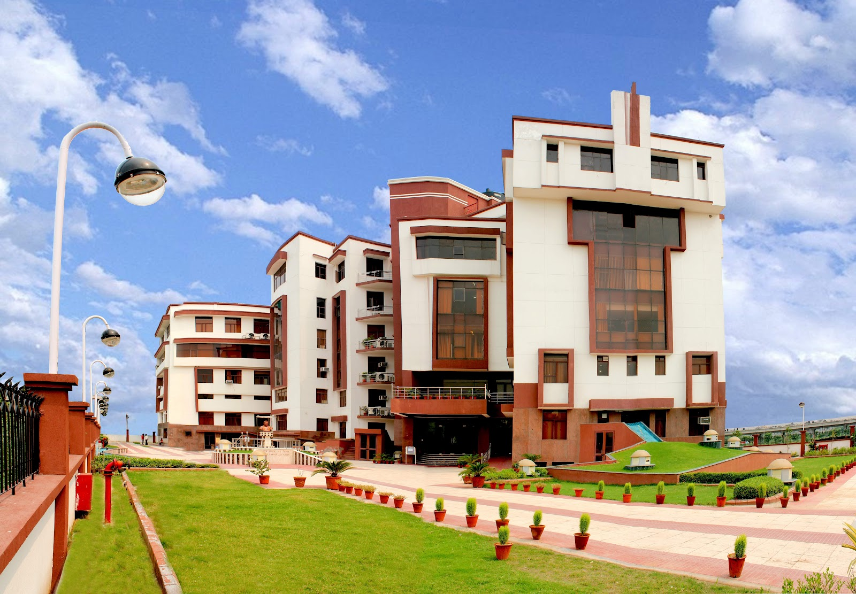

**The Institute**

**Lal Bahadur Shastri Institute of Management, Delhi is a premier and dynamic institute of Management and Information Technology Education.**

**Established by the Lal Bahadur Shastri Educational Society in 1995, it has emerged as one of the top business schools in the country. It takes pride in being one of the foremost institutes in providing value based management education, thus developing professionals with a humane and pragmatic approach on the march towards corporate excellence. The institute has state-of-the-art infrastructure and a fully air-conditioned building in Dwarka, New Delhi. The campus of the institute at Dwarka, is located near the Delhi Metro line and thus, can be reached with ease by students living anywhere in Delhi/NCR. Excellent arrangements for boarding, lodging, and other facilities have been made in Dwarka itself, for students desirous of residing near the campus. The campus offers excellent infrastructural facilities and is equipped with a splendid auditorium, having capacity of 300 people; a huge library spanning two floors, which would be the envy of every business school in the country and has also an open-air theatre.**

**Lal Bahadur Shastri Institute of Technology and Management, Indore (LBSITM), is our recent initiative that offers two year full Time Regular Post Graduate Diploma in Management.The Institute duly recognized by AICTE, Ministry of HRD, Govt. of India is to be modeled after Lal Bahadur Shastri Institute of Management, New Delhi.**

**LBSIM is recognized by All India Council for Technical Education (AICTE), Ministry of Human Resource Development, Government of India for the following courses:**

**Post Graduate Diploma in Management (General)- Full-Time**

**Post Graduate Diploma in Management (Finance)- Full-Time**

**Post Graduate Diploma in Management (Executive)- Full-Time**

**Post Graduate Diploma in Management - Part Time**

**Masters in Computer Applications (Affiliated to Guru Gobind Singh Indraprastha University, Delhi)**

**The Association of Indian Universities (AIU) has recognized the Two Year Full-Time PGDM as equivalent to MBA Degree by an Indian University.**

**Guru Gobind Singh Indraprastha University, Delhi has approved LBSIM as Research Centre for Ph.D research work.**

**At LBSIM, the Focus is on:**

* **Developing professionals with ‘Vision & Versatility’ in accordance with ‘Ethics’, ‘Values’, and ‘Principles’ of Shri Lal Bahadur Shastri.**
* **Producing, grooming, and nurturing professionals with a humane and pragmatic approach, the essence of which lies in ‘teamwork’.**
* **Supplementing classroom learning with real-life field experience through a mandatory ‘Corporate Interface Day’, conducted weekly.**
* **Inculcating and nurturing the habit of ‘lifelong learning’, through mandatory hours every day, for accessing, retrieving, and using select learning resources.**
* **Imparting time-tested skill sets in lab environment; for example, imparting communication skills through audio-video recordings/displays.**
* **Providing regular class inputs by way of conceptual as well practical insights by eminent corporate stalwarts.**
* **Prompting and encouraging students to ideate with and implement creative/innovative ideas through various formal/informal student bodies’ like grids, clubs, etc.**
* **Constant curriculum review and updating through a three-way interaction process: Student/Alumni-Faculty-Industry.**

**LBSIM also offers :**

* **NSE Certified Capital Market Professional Course (In collaboration with NSE)**
* **The LBS Entrepreneurial and Incubation Center (LBSEIC)**
* **LBS Risk Management Centre (LBSRMC)**
* **Mentor-Mentee Program**

**Other Major Programmes and Activities :**

* **Management Development Programmes**
* **Faculty Development Programmes**
* **Management Development Programmes**
* **Research and Consultancy**
* **Conferences, Seminars, and Workshops**